Bartholomew Dias
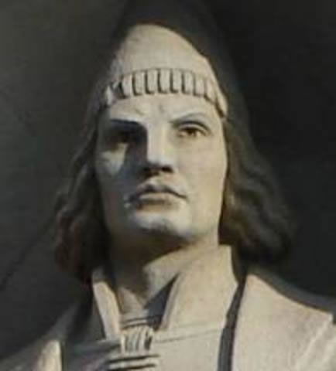
Bartholomew Dias was a Portuguese nobleman who was chosen by the King of Portugal to lead an expedition that would sail around the horn of Africa for the purposes of finding a trading route by sea to India. In addition, Dias would search for the Kingdom of Prester John, who was said to rule over a vast Christian empire, filled with riches and magical creatures, somewhere in Asia. During the time of Dias’ expedition, the seas and oceans were largely unexplored and water routes betwen Europe and Asia had not yet been established.

Dias’s ship, the São Cristóvão, and two other ships left Portugal in 1487 and set sail south along the west coast of Africa. By December of 1487, Dias had reached the west African nation of Angola. As his expedition continued south, it endured a violent storm which caused the expedition to stray south and west to a latitude well south of the horn of Africa. Turning northeast, Dias entered modern-day Mossel Bay, about 250 miles east of present-day Capetown. Although Dias wanted to sail east to Asia, his crew refused and Dias was forced to return to Portugal. Early into the return trip, Dias discovered the Cape of Good Hope in May of 1488. Dias named it "the Cape of Storms," but it was renamed by the Cape of Good Hope by the Portuguese King John II as it represented a monumental discovery and potential trade with Asia. By 1497, Portuguese explorer Vasco da Gama had successfully sailed around Africa to India and Asia. Bartholomew Dias is thought to have died in 1500 when a ship he was on wrecked during a terrible storm near the Cape of Good Hope.

Vasco da Gama

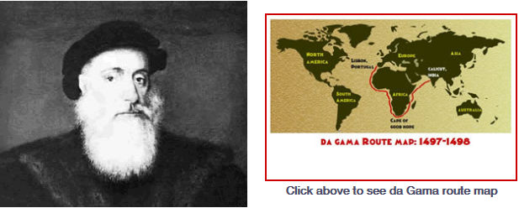

Introduction
Vasco da Gama was born in 1460 to a wealthy Portuguese family in Sines, Portugal. Vasco’s father was also an explorer and was supposed to make the epic journey from Portugal to India that would eventually make his son famous. He died, however, before he could successfully complete the journey. In the late 1400’s, Portugal was desperately trying to find a sea route to Asia so they could obtain spices for cheap prices. Explorers such as Bartholomew Dias had made some progress in making the journey, but none had been able to sail around the southern tip of Africa at the Cape of Good Hope (where the Atlantic and Indian Ocean meet ) and into the Indian Ocean.

Sailing to India
In 1497, Portuguese King Manuel I financed a voyage led by Vasco da Gama. Many, however, still believed the trip to be impossible, because they did not think the Atlantic Ocean connected with the Indian Ocean. Da Gama believed it was possible and left Lisbon, Portugal on July 8, 1497, with four ships full of criminals and set sail on the Atlantic. After five months on the Atlantic, da Gama and his crew successfully sailed around the Cape of Good Hope and into the Indian Ocean on November 22. After making several stops along ports in the eastern African nations of Kenya, Mozambique and others, and after struggling with Muslim traders in the Indian Ocean who did not take kindly to interference with their trade routes, da Gama reached Calicut, India on May 20, 1498.

Back to Portugal
In India, da Gama traded extensively for Asian products and spices. Although he was initially well-received in India, he eventually wore out his welcome. Da Gama left India in August of 1498, after he was told to pay a heavy tax and to leave the goods he traded for. Da Gama refused to leave the goods, and only left India after taking Indian hostages. By the time Da Gama returned to Lisbon in 1499, many of his crew members had died of scurvy (a disease caused by a lack of vitamin-C), and he had become a hero. King Manuel I made him an admiral.

The Tyrant
In 1502, King Manuel sent da Gama back to India. This time, however, da Gama came with 20 armed ships to prevent problems with Muslim traders. In one case, da Gama ordered the massacre of a Muslim vessel with 380 people on board. When he reached India, he brutally murdered many Muslims to demonstrate his power, and bombarded Calicut to force the Portuguese will on Asian trading markets. Da Gama’s conquests paved the way for future conquests in Asia.
Da Gama returned to Portugal in 1503. He died in India in 1524 from an illness.

Christopher Columbus

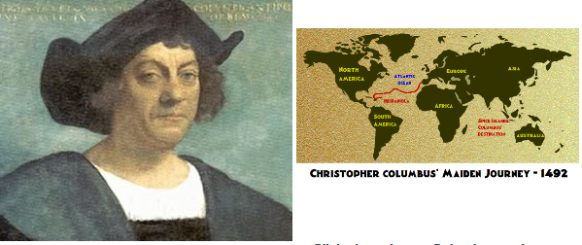

Heading West to Reach the East
Christopher Columbus was born in Genoa, Italy in 1451. His career in exploration started when he was very young. As a teenager he traveled the seas and eventually made Portugal his base. Columbus came to believe that the East Indies (present day Indonesia and surrounding islands) could be reached by sailing west through the Atlantic Ocean. He appealed to the kings of Portugal, France and England to finance a westward trip to the Indies, but all denied his request. After ten years of monumental efforts but fruitless results, King Ferdinand and Queen Isabella of Spain agreed to finance Columbus in the hopes of acquiring great wealth. On August 3, 1492, Columbus, crew, and three ships, the Nina, Pinta, and Santa Maria, left Palos, Spain and headed westward.

Land sighted!
After stopping in the Canary Islands off the coast of Africa, Columbus’ ships hit the open seas. Covering about 150 miles a day, the trip was long and arduous. The crew was afraid of sea monsters and grew more restless every day that land was not sighted. Columbus offered a reward for the first person to sight land. On October 12, a crew member aboard the Pinta sighted one of the Bahama Islands. Columbus set foot on what he believed was one of the Spice Islands, a group of islands in Asia (now known as Indonesia), where valuable spices and riches came from. He named the land San Salvador. Columbus failed to find the riches he expected, and continued to search for China. He next visited Cuba and Hispaniola (Dominican Republic). He encountered native peoples who he named “Indians” because he believed they were inhabitants of the Indies.

I Did Find a Shortcut to the Indies!
Columbus returned to Spain a hero. He was named Viceroy of the Indies. He soon returned to the New World but never found the riches he expected. Some began to believe that Columbus had found “a new world” rather than a shortcut to the Indies.

Legacy
Christopher Columbus is credited with discovering the continent of North America, although he probably wasn’t the first explorer to see the continent, and he believed until his death that the islands he encountered were in the Asian continent. His discoveries were instrumental in the establishment of Spanish colonies in North America.
Juan Ponce de Leon

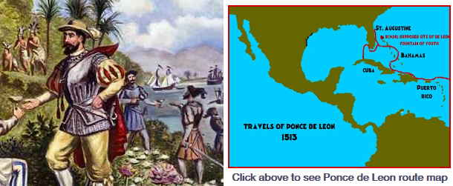

Early Life

Juan Ponce de Leon was born in 1460 in Santeveras, Spain. He was an explorer and fighter from an early age and helped fight the Muslims in southern Spain in the early 1490’s. He was on board Christopher Columbus’ second expedition to the Americas in 1493. Rather than returning to Spain, the adventurer remained at an island called Santo Domingo (now called the Dominican Republic.)

The Conquistador

De Leon was soon appointed as the governor of the Higuey region of Santo Domingo. Like many Spanish explorers, he was bloodthirsty for gold. When he heard rumors that a nearby island called Borinquen (now Puerto Rico) was full of gold, he invaded the island and brutally conquered the natives. He was soon appointed governor of the island, but lost his title in 1511 because of his extreme brutality toward the natives.

The Search for the Fountain of Youth

De Leon’s misfortunes as governor did not stop him from sailing the seas looking for gold and the Fountain of Youth. After returning to Puerto Rico, de Leon took three ships and 200 men on a mission to explore lands to the north. De Leon hoped to find the Fountain of Youth, a mythical spring that was said to make anyone who drank its water young forever. After making several stops at Caribbean islands, and conquering the island of Bimini, de Leon and his men reached the east coast of Florida (St. Augustine) on April 2, 1513. He named the land “Pascua de Florida”, or Feast of Flowers, because he discovered it on Palm Sunday. He claimed all of the land for Spain.

Captain General

On April 8, 1513, de Leon and his men left northern Florida and sailed south along the Gulf Stream. After a fight between his men and natives in southern Florida, he sailed to Cuba. He tried to sail back to Bimini, but could not find it. De Leon soon returned to Puerto Rico where he sacked a rebellion of natives against Spanish rule. After returning to Spain, he was named Captain General by the King on September 27, 1514.

Hernando de Soto

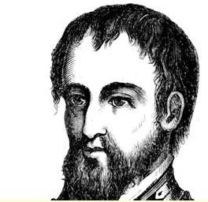

Glory and Conquest
In 1514, de Soto sailed with the Spanish governor of Panama where he assisted in the conquest of Central America. From an early age, de Soto gained a reputation for bravery, intellect, and brutality. In 1528, de Soto became regidor of Guatemala and sailed from there to the Yucatan Peninsula of Mexico, hoping to find a passage from the Atlantic to Pacific Ocean that would enable Spanish trade with the East Indies. The expedition ultimately failed, and de Soto joined Francisco Pizzaro and his conquest of South America. Because de Soto had a major part in the conquest of the Incan Empire, he became fabulously wealthy upon his return to Spain. De Soto was made governor of Cuba, and was expected to colonize the mainland of North America. He chose 620 men for the voyage from Cuba to the interior of North America. De Soto hoped to find the passage from the Atlantic Ocean to the Pacific Ocean.

Into the Southeast in Search of Gold
In May of 1539, de Soto, 620 men, and 220 horses land at Charlotte Harbor, Florida. He named it Espíritu Santo after the Holy Spirit. The expedition then traveled north through the peninsula of Florida where they endured native ambushes along the way. By 1540, de Soto had reached Georgia and South Carolina, in pursuit of gold mines rumored to exist in the region. Unsuccessful in his attempts to find gold, de Soto continued north into the Appalachians of North Carolina. Once again, there was no gold to be found, but de Soto spent a month in the mountains resting his horses before traveling to Tennessee and then south again toward the Gulf of Mexico to meet supply ships. While traveling south, de Soto and his men were ambushed by the Choctaw people near their fortified city of Mabila. In the battle, 20 of de Soto’s men were killed and thousands of Choctaw died. Despite the victory, de Soto and his men lost most of their possessions and many had become sick. Consequently, de Soto directed his expedition back north into Tennessee where they spent the winter.

Discovery of the Mississippi River
After the winter, de Soto’s expedition traveled south west. On May 8, 1541, Hernando de Soto discovered the Mississippi River, although de Soto was not exactly thrilled with the finding. The Mississippi River was a huge, broad river that stood in the way of his expedition. It took over a month to build the appropriate floats to navigate across the river. Once across the river, the expedition continued into Arkansas, Oklahoma, and Texas. They spent the next winter on the Arkansas River. Things began falling apart for de Soto, when Juan Ortiz, his faithful interpreter died. The death of Ortiz made communication with native peoples and the procurement of food much harder. Furthermore, while in Arkansas, de Soto and his men clashed with the Tula people which took a great toll on the already weakened men. On May 21, 1542, Hernando de Soto himself died of a fever.

Hernán Cortés

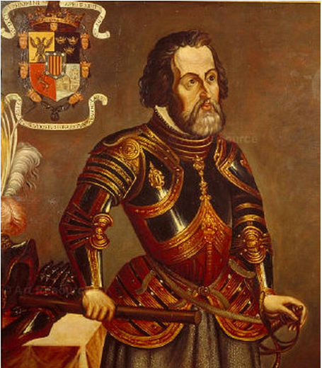
Hernando Cortez (Hernán Cortés was his real name) was born in Medellín, Spain in (or around) 1485. He was a Spanish conquistador, known for conquering the Aztec empire of Mexico. He came from a noble family and was well educated. From an early age, however, Cortes was described as a trouble-maker, mischievous, quarrelsome and even ruthless. Excited by tales of the New World, he sailed to Hispaniola in the West Indies at the age of 19. During his stay on Hispaniola, he served as both a farmer and notary (a public official), before sailing on an expedition to Cuba in 1511, led by Diego Velásquez. Cortez proved a natural leader, and became mayor of Santiago, Cuba.
In the fall of 1518, he set off for Mexico, on his own expedition with 600 soldiers and sailors and 16 horses on 11 ships. They landed on the Mexican coast in early 1519 at Tabasco on the Yucatan peninsula, where he and his army defeated a group of natives. While there, Cortez manage to gain favor among other natives, and he fathered a son with a native woman named Marina, who also served as an interpreter. Cortez next conquered the city of Veracruz. It was at Veracruz, where he began making plans to visit Montezuma and the Aztec empire despite orders from Spain to cancel further explorations. On the way to the Aztec capital of Tenochtitlan, Cortez allied with several tribes that were enemies of the Aztecs and massacred others, possibly to instill fear among the Aztecs.
On November 8, 1519, Hernán Cortéz and his crew entered Tenochtitlán, where they were initially welcomed into the city with lavish gifts adorned with gold and precious gemstones. Cortes remarked that the island capital of Tenochtitlan was among the most beautiful and advanced cities in the world, although he was horrified by the Aztec practice of sacrificing prisoner of wars to their Gods. These initial gifts, however, made the Spanish bloodthirsty for more. Meanwhile, Cortez learned that the Aztecs considered him an emissary (representative) of their central God Quetzalcoatl. Cortez and his men took advantage of their status and kidnapped the Aztec chief Montezuma, who was later killed. The Spaniards quickly wore out their welcome and managed to escape the island city in the middle of the night. Cortez suffered hundreds of casualties and lost much of the treasure he had looted in the narrow escape. The Spanish, did however, initiate the collapse of the Aztec empire by infecting the Aztecs with Smallpox. With the Aztec capital in ruins, and the population dying from disease, Cortez returned and founded Mexico City atop the ruins of Tenochtitlan in 1521. He was appointed governor of New Spain in 1522 by King Charles I. Mexico would be ruled by Spain for three centuries after the conquest.
In 1524, Cortez traveled to Honduras to stop a rebellion against him, and when he returned to Mexico, he found he had been removed from power by Ponce de Leon, who may have believed that Cortez was becoming too powerful. Cortez went back to Spain to plead his case with the king but was denied his governorship. He eventually returned to the New World where he explored and named California. He retired in Spain and died in 1547.

Giovanni da Verrazano

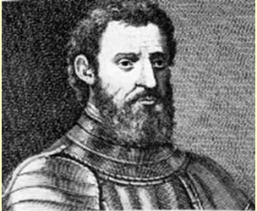

Giovanni the Pirate
Giovanni da Verrazano was born sometime around 1485 in his family’s castle (Castello Verrazzano) in Val did Greve, Italy. In 1507, Verrazano moved to Dieppe in the hopes of pursuing a career in navigation. While in Dieppe, he made voyages to the Eastern Mediterranean. He spent many years as a pirate, preying on Spanish and Portuguese sea vessels. He was responsible for stealing nearly two million dollars worth of gold from Spanish vessels that were bringing gold and jewels back from Mexico, stolen from the Aztec Empire.

Wait, is this the Pacific Ocean or the Atlantic Ocean?
In 1524, Verrazano was chosen by king Francis I of France to search for a “Northwest Passage” to Asia through North America. He left aboard La Dauphine in January of 1524. On March 1, 1524, he reached Cape Fear, North Carolina and proceeded north to explore the coastline. Verrazano believed he saw the Pacific Ocean as he explored the North Carolina coast on the other side of a narrow strip of land. He had actually found the Pamlico Sound, which is part of the Atlantic Ocean. Verrazano’s error in judgment resulted in erroneous maps printed in Europe. The maps depicted North America as being split into two parts, connected by a narrow strip of land. The error took over a century to correct.

Exploring the North-Atlantic Coast of North America
As Verrazano explored the Atlantic coast of North America farther north, he discovered New York Harbor, Block Island and Narragansett Bay. Because he often anchored far off-shore, Verrazano missed discovering the Chesapeake and Delaware Bays. He sailed farther north to Maine and Newfoundland before returning to France. Verrazano would make two more trips to the Americas. On the second trip, he was killed by natives on the island of Guadalupe. Today, New York Harbor’s Verrazano Narrows Bridge commemorates his epic journey.

Ferdinand Magellan
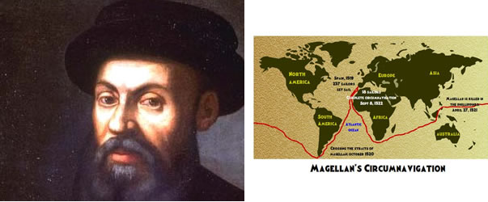

Early Life
Ferdinand Magellan was born in Sabrosa, Portugal in 1480 into a noble family. After serving as a court page for two years, his adventurous spirit led him to a career as an explorer. In 1506, Magellan went to the Spice Islands (Indonesia) to participate in several military and exploratory expeditions. In 1510, he was promoted to the rank of captain. In 1512, he was stationed in Morocco and made preliminary plans to find a western shortcut to the Spice Islands. Unfortunately, Portugal’s king, Emmanuel, refused to finance his journey, and in 1517, he renounced his Portuguese citizenship. He promptly offered his services to King Charles I of Spain. Charles I agreed to finance Magellan’s trip in the hopes of becoming the king of the richest nation in the world.

Circumnavigation
On September 20, 1519 Magellan and 237 crew members set sail on five ships from Sanlucar de Barrameda in the hopes of finding a shortcut to the Spice Islands. After three long months of sailing the Atlantic, Magellan and his crew anchored near Rio de Janeiro in the present day South American nation of Brazil. After trading with local natives, Magellan and his men quickly set sail again, ever worried about the threat of Portuguese ships. As the expedition continued, the weather got worse and several crew members were executed for trying to take over the ship. Others were starving or suffering from frostbite. As the ships neared the southern tip of South America, one smashed into the beach and lost all supplies. Nevertheless, in October of 1520, Magellan and his crew crossed the treacherous straits at the tip of South America, which became known as the Straits of Magellan.

Trouble in the Pacific Ocean
As the expedition passed through the straits, they entered the vast Pacific Ocean. Things got worse before they got better. The crew suffered from extreme hunger and were forced to survive by eating rats, sawdust, leather and even maggots. At least 20 men died from disease, particularly Scurvy (caused by a lack of Vitamin C) and starvation. On March 6, the ships finally reached land – the Pacific island of Guam. Nevertheless, the crew members were able to collect clean water and food, despite being on the alert for attacks by the natives. Soon, the crew sailed to the Philippine Islands, where they converted natives to Christianity. During an attempt to convert the native chief, Mactan, to Christianity, Magellan was wounded by an arrow that was driven through his foot by a native warrior. Mactan, who had become upset with Magellan’s insistence that he convert, ordered his warriors to attack. They killed Magellan on April 27, 1521. Most of Magellan’s crew escaped and set sail.

Return to Spain
With the loss of their leader, Juan Sebastian Del Cano took control of the ship and sailed for Spain. Only two ships and 47 men remained. Portuguese forces captured one of the ships, leaving the Victoria as the only ship left. Severe storms and Portuguese attacks battered the Victoria. As Portuguese forces bore down on the expedition near the Cape Verde Islands, Del Cano was forced to continue toward Spain without supplies or rest. Finally, on September 8, 1522, The Victoria made it back to Spain with only 18 men surviving, hence completing the first circumnavigation of the world.

Columbian Exchange
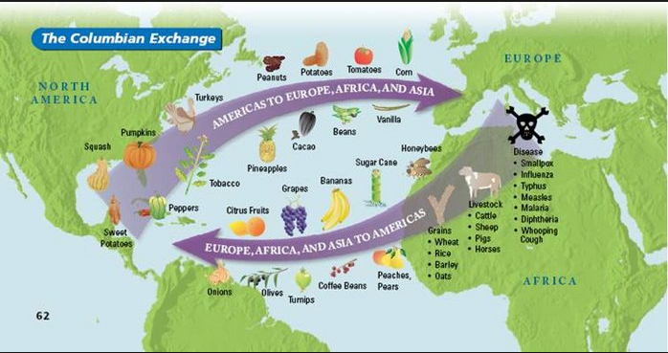
The Columbian Exchange was the widespread transfer of animals, plants, culture, human populations, technology, and ideas between the American and Afro-Eurasian hemispheres in the 15th and 16th centuries, related to European colonization and trade after Christopher Columbus's 1492 voyage.^{[1]} Invasive species of flora and fauna and communicable diseases were a byproduct of the Exchange.
The contact between the two areas circulated a wide variety of new crops and livestock, which supported increases in population in both hemispheres, although diseases initially caused precipitous declines in the numbers of indigenous peoples of the Americas. Traders returned to Europe with maize, potatoes, and tomatoes, which became very important crops in Europe by the 18th century.

Technology
Caravel:
The Caravel was a ship that had many uses. These ships were from small to medium. They could be used as cargo ships, warships, patrol or dispatch boats and also pirate ships. They were mainly used for fishing. The Caravel was from 50 to 200 tons. These ships were cheap and you could get them in shape for working very easily. They were known for their speed and maneuverability. So these ships were used by explorers to explore.
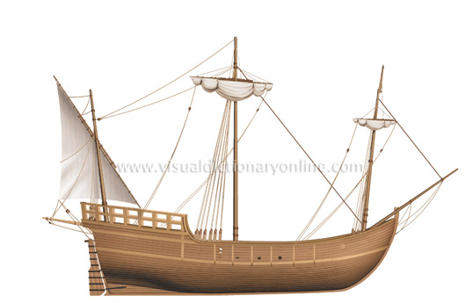
Astrolabe:
The Astrolabe is an angle and altitude measuring tool. The Astrolabe was first used for astronomy and astrology. It could have been invented by Hipparchus (Greek astronomer and mathematician). It was later used by sailors. The first use at sea was recorded to be in 1481. It was used on a voyage down the African coast by Portuguese explorers. So this tool helped sailors measure the angle of the sun which could then be converted to find latitude. This tool was more accurate at land then at sea.
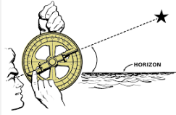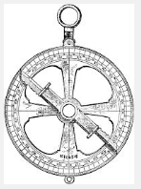

Magnetic Compass and Compass Rose:
The magnetic compass was a compass that had a magnetized needle supporting a magnetic card. This compass showed from four to eight directions. This innovation helped the Age of Exploration flourish because it showed explorers what direction they were headed. So basically it helped explorers reach their destination. The compass rose also told direction.

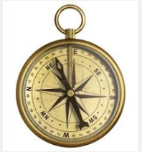

Timekeeping and Navigation:
Timekeeping and Navigation played a large part in helping the Age of Exploration flourish. Navigation was important because sailors needed longitude and latitude to travel exactly to the destination they wanted to travel. Without longitude and latitude people wouldn't be able to determine location.

Timekeeping was important because it helped people keep time and plan better. It helped sailors know when it was time for their duty and it also helped determine how fast the ship was going during a certain amount of time. Many instruments such as the sand glass were used to help keep time.
