European Explorers of the Renaissance and Reformation Era
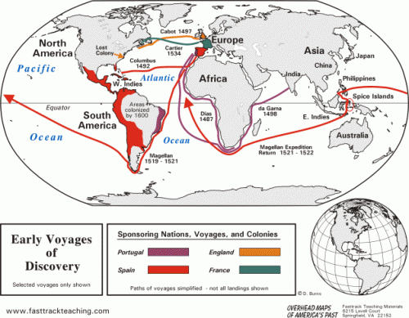
Draw the path and give the date of the following explorers or settlement. Use different colors or line patterns so you can tell them apart. Change the lines on the
Cabot Columbus Verrazano Cartier Jamestown New Netherland
Da Gama Cortez Raleigh Magellan Hudson Champlain

