Name: __________________
Circular Flow Model Activity
Directions: Answer the questions below
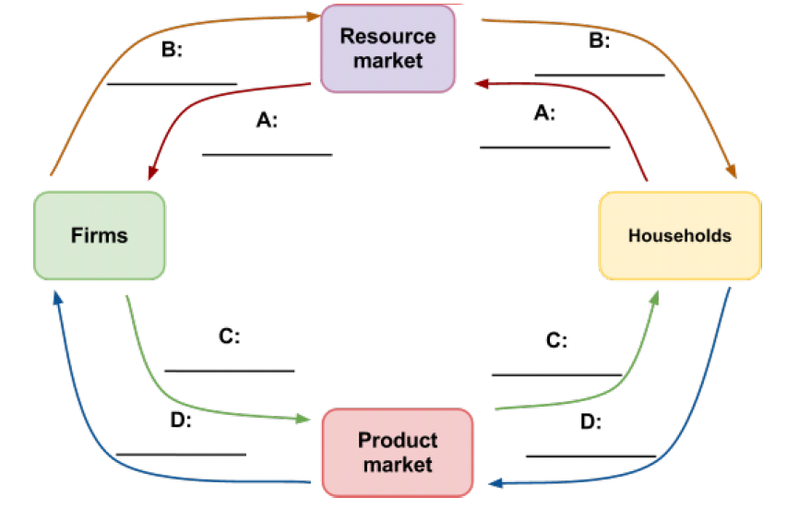

1. Fill in the blank lines on the circular flow model below. What is occurring/being traded in each step?
a. __________________________________________
b. __________________________________________
c. __________________________________________
d. __________________________________________

2. In the resource market:
a. What is the role of firms?

b. What is the households?

3. In the product market:
a. What is the role of firms?

b. What is the role of households?

4. Give an example of a transaction someone in your household made in the factors market this month.

5. Give three examples of transactions you made this week in the product market.

6. What determines the amount of income a household will earn in the resource market? Why do some households earn higher incomes than others?

7. What determines the amount of money a firm will earn in the product market? Why do some firms earn so much more money than others in a market economy?

8. What is the goal of a household in a market economy? Based on this simple goal, what is the best way for a household to achieve it?

9. What is the goal of a firm in a market economy?

10. What makes the exchanges that take place in a market economy “mutually beneficial”?

11. What role does money play in the circular flow model?

12. What role do prices play in the circular flow model?

13. What role or roles does the government play in our economy?

14. What role do banks play in our economy?

15. Prediction: What would happen to the circular flow of a nation’s economy if the nation opened up to
free, international trade with the rest of the world?

16. Name 2 ways that capital can “leak” out of the circular flow of goods and services in America.

