Setting up WWI

Allies

Central Powers

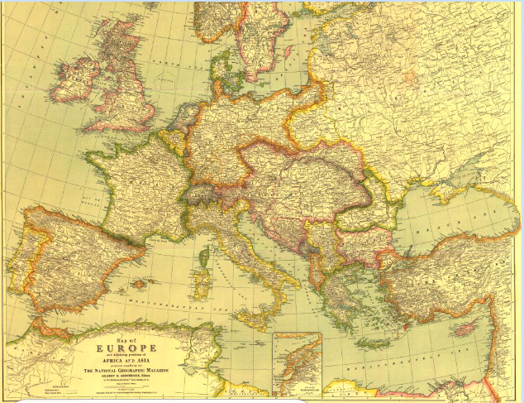
Queen Victoria of England –

King George of England –

Wilhelm of Germany –

Nicholas Romanov of Russia –

1853 –

1854 –

Otto von Bismark –

Franco-Prussia War –

Garibaldi –

Boer wars –

Russo-Japanese War –

Moroccan Crisis 1905 –

Moroccan Crisis 1911 –

Bosnian crisis 1908 –

Bosnian crisis 1912-1913 –

Second Industrial revolution –

Marxism –

M –

A –

I –

N -

